**Simple dev-test-prod enviornment** **Levels of GIT system**

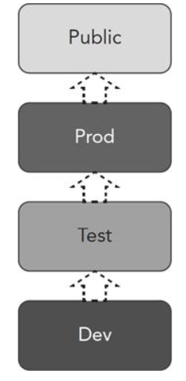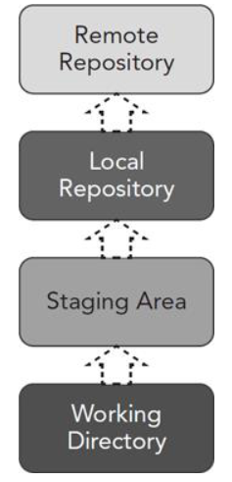

**Core Commands for Moving Content between Levels in Git**

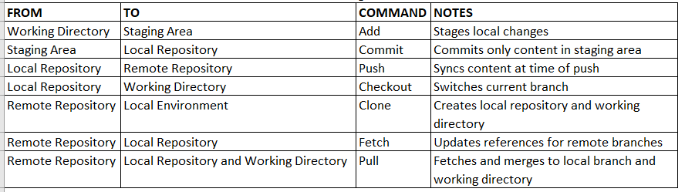

**GIT in one picture:**

